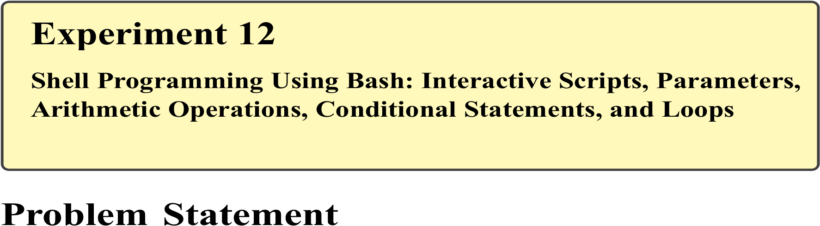
Manual execution of commands in Linux can be repetitive and inefficient. Bash shell scripting enables users to automate tasks, accept user input, perform arithmetic operations, make decisions using conditional statements, and execute repetitive tasks using loops. These capabilities are essential for system administration, automation, and cyber security workflows.
The problem is to write and execute Bash shell scripts that demonstrate interactive input, positional parameters, arithmetic operations, conditional statements, and loop constructs, thereby automating basic computational and logical tasks

Shell Programming
Shell scripting is a method of automating tasks by writing a sequence of Linux commands in a script file executed by the shell.
Interactive Scripts
Interactive scripts accept input from the user during execution using the read command.

Positional Parameters
Shell scripts accept command-line arguments using:
- $0 – Script name
- $1, $2, ... – Positional parameters

Arithmetic Operations
Arithmetic can be performed using:
$((expression))

Conditional Statements
Decision-making constructs include:
- _{if}
- if-else
- _{elif}

Loops
Loops execute commands repeatedly:
- _{for}
- while

Commands Used
read | Accept user input
echo | Display output
$(( )) | Arithmetic operations
if, elif, else | Conditional statements
for, while | Loop constructs
chmod | Make script executable

Procedure

A. Interactive Shell Script
- Create a script file:
nano interactive.sh
- Enter the following code:
#!/bin/bash echo "Enter your name:" read name echo "Welcome $name"
- Save and exit.
- Make the script executable:
chmod +x interactive.sh
- Execute the script:
./interactive.sh

B. Script Using Positional Parameters
- Create another script:
nano params.sh
- Enter the following code:
#!/bin/bash echo "Script Name: $0" echo "First Argument: $1" echo "Second Argument: $2"
- Execute:
./params.sh Linux Bash

C. Arithmetic Operations
- Create script:
nano arithmetic.sh
- Enter:
#!/bin/bash a=10 b=5 sum=$((a + b)) echo "Sum = $sum"

D. Conditional Statement
- Create script:
- nano condition.sh
- Enter:
- #!/bin/bash
- echo "Enter a number:"
- read num
- if [ $num -gt 0 ]
- then
- echo "Positive number"
- else
- echo "Zero or Negative number"
- fi

E. Loop Constructs
- Create for-loop script:
- nano loop.sh
- Enter:
- #!/bin/bash
- for i in 1 2 3 4 5
- do
- echo "Iteration $i"
- done

